

**Date:** 19th Nov 2024

**Road Safety Club, NSCBM G.C. Hamirpur**

**Report of Inauguration Session**

Reference: -

1. Directorate of Transport letter No. TPT-LA(22)/RSC/ Education-Action Plan-21-20384 dated 10th Sep 2024.
2. Directorate of Higher Education letter No. EDN-HE(21)F(10)13/2024-Road Safety dated 11th Nov 2024.

Road Safety Club has conducted “**Inauguration Session**” on **19th Nov 2024** in the college campus to raise awareness among students. Principal Dr. Pramod Patial, Asst. Professor Vinod Chand (Coordinator RSC) and Asst. Professor Apoorva Thakur were present during the session along with 60 in numbers, Road Safety Club Members & Students. During the session, brief lecture was delivered to the students about road safety. Road Safety Management Committee was formed with the nomination of Asst. Professor Kalpna Bhandari, Asst. Professor Shilpa Thakur and Asst. Professor Apoorva Thakur for the Academic Session 2024-25. SUO Suraj Sharma and UO Sanjna Thakur were nominated as Road Safety Club Leader and Road Safety Club Assistant Leader respectively. Schedule for the Road Safety Activities for Academic Year 2024-25 is as follows: -

|  |  |  |
| --- | --- | --- |
| **Date** | **Name of Activities** | **Remarks** |
| 19.11.2024 | Inauguration Session of Road Safety Club |  |
| 23.11.2024 | Slogan Writing Competition on Road Safety |  |
| 26.11.2024 | Lecture on Road Safety Awareness to NCC Cadets |  |
| 18.12.2024 | Lecture on Road Safety Awareness to all UG/PG students |  |
| 20.12.2024 | Rally on Road Safety Awareness |  |
| 11.02.2025 | Quiz Competition on Road Safety |  |
| 15.02.2025 | Essay Writing/ Declamation Competition on Road Safety |  |

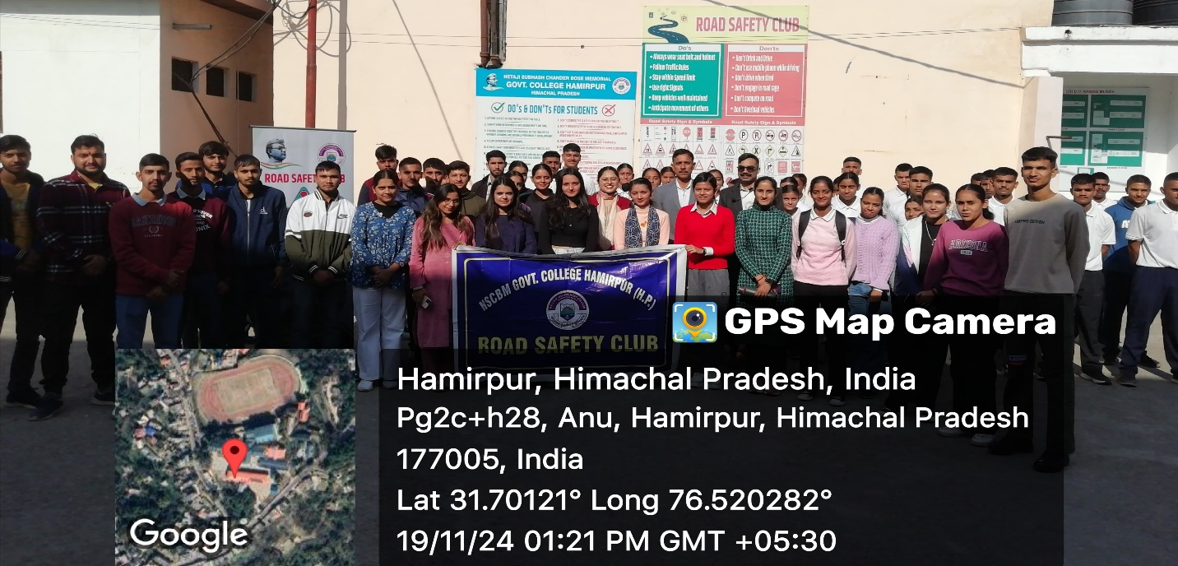

Road Safety Club Coordinator Principal