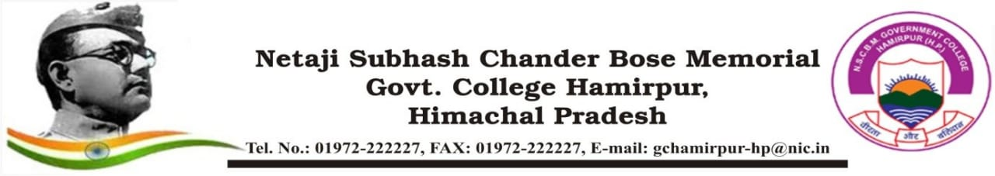

**ROAD SAFETY CLUB ACTIVITY ORGANIZED REPORT**

**(Academic Year: 2024-25)**

|  |  |  |
| --- | --- | --- |
| **Name of the activity organized** | | Nukkad Natak on Road Safety |
| **Title of the activity** | | Nukkad Natak on Road Safety |
| **Date of the activity organized** | | 08 Mar 2025 |
| **Name of the Coordinator/Convener** | | Mr. Vinod Chand,  Asst. Professor  (Public Administration) |
| **Notice/Circular/Brochure** (attach as separate file) | | EDN-GC-HMR/(Road Safety)/ 2024-25/1488 dated 26 Dec 2024 & Notice of even no. dated 05 Mar 2025 |
| **Place of the activity** | | College Campus |
| **No of participants { students (male + female) and staff }** Give Attendance List of Students as separate file | | 22 students + 200 students (Spectators) and 3 Staff personnel |
| **Objective of activity** | | To raise awareness among students and society on Road Safety |
| **Outcome of activity** | | Awareness of Road Safety among students and society as a whole. |
| **News published if any**   Punjab Kesari (Hamirpur, H.P. edition)  dated 09 Mar 2025 | | |
| **Photo Gallery** (Preferably Geo - tagged) | | |
| **Signature of Coordinator/Convener** | **Signature of Principal**  **With stamp** | |