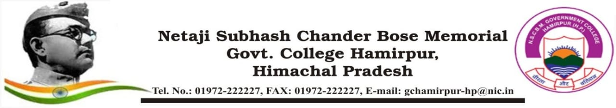

**ROAD SAFETY CLUB ACTIVITY ORGANIZED REPORT**

**(Academic Year: 2024-25)**

|  |  |
| --- | --- |
| **Name of the activity organized** (Conference/Seminar/Workshop/Guest Lecture/Visit etc.) | Painting Competition on Road Safety |
| **Title of the activity** | Painting Competition on Road Safety |
| **Date of the activity organized** | 10th Feb 2025 |
| **Name of the Coordinator/Convener** | Mr. Vinod Chand,  Asst. Professor  (Public Administration) |
| **Name, Designation and brief detail of the Resource Person(s)** | -- |
| **Notice/Circular/Brochure** (attach as separate file) | EDN-GC-HMR/(Road Safety)/ 2024-25/1146 dated 06 Feb 2025 |
| **Place of the activity** | Road Safety Club, Room No. 164, Kargil Bhawan, College Campus |
| **No of participants [students (male + female) and staff]**  Attendance List of Students as separate file | 15 students and 04 Staff personnel |
| **Name of sponsoring organization** | -- |
| **Objective of activity** | To raise awareness among students and society on Road Safety |
| **Outcome of activity** | Awareness of Road Safety among students and society as a whole. |

|  |  |
| --- | --- |
| **News published if any**   Punjab Kesari (Hamirpur, H.P. edition) dated 11 Feb 2025 | |
| **Photo Gallery** (Preferably Geo - tagged) | |
| **Signature of Coordinator/Convener** | **Signature of Principal**  **With stamp** |