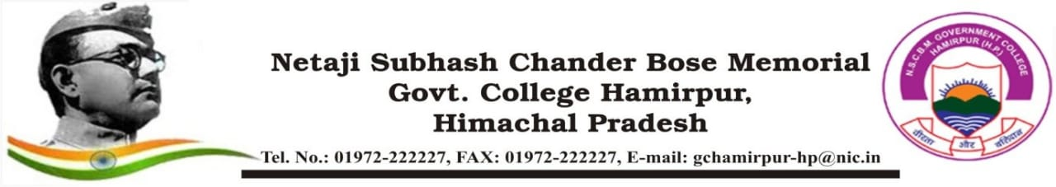

**COLLEGE ACTIVITY ORGANIZED REPORT**

**(Academic Year: 2024-25)**

|  |  |  |
| --- | --- | --- |
| **Name of the activity organized** (Conference/Seminar/Guest Lecture/Visit etc.) | | Drugs Awareness Programme and Rally against Drugs |
| **Title of the activity** | | Drugs Awareness Programme |
| **Date of the activity organized** | | 05 Feb 2025 |
| **Name of the Coordinator/Convener** | | Dr. Shashi Kr Dhiman,  Vice Chancellor (HPTU) |
| **Name, Designation and brief detail of the Resource Person(s)** | | Honorable Governor Himachal Pradesh, Shri Shiv Pratap Shukla |
| **Notice/Circular/Brochure** (attach as separate file) | | EDN-GC-HMR/ 2024-25/ 1127 dated  05 Feb 2025 |
| **Place of the activity** | | Circuit House, Hiranagar to Gautam Group of Colleges, Hamirpur |
| **No of participants [students and staff]**  Give Attendance List of Students as separate file | | 51 students and 3 Staff personnel |
| **Name of sponsoring organization** | | HPTU |
| **Nature of sponsorship**  **(Total grant received if any)** | | -- |
| **Objective of activity** | | To raise awareness among students and society on Drugs |
| **Outcome of activity** | | Awareness on Drugs, Drug Demand Reduction among students and society as a whole. |
| **News published if any**   Punjab Kesari, Dainik Bhaskar, Dainik Jagran, Divya Himachal (Hamirpur, H.P. edition)  dated 06 Feb 2025 | | |
| **Photo Gallery** (Preferably Geo - tagged) | | |
| **Signature of Coordinator/Convener** | **Signature of Principal**  **With stamp** | |