

**Subject: Report on Slogan Writing Competition on Road Safety Theme**

Reference: Notice No. EDN-GC-HMR/(Road Safety)/ 2024-25 dated 21 Nov 2024.

Slogan Writing Competition based on Road Safety Theme was conducted on 23rd Nov 2024 at 11:00 AM in Kargil Bhawan, Room No. 164 onwards by Road Safety Club, NSCBM Govt. College Hamirpur, (H.P.) under the supervision of Road Safety Club Coordinator Assistant Professor Vinod Chand. Students from various streams participated in the competition. A total of 16 students participated in the “Slogan Writing Competition”. The competition will inculcate a sense of responsibility and safety among all stakeholders on the road and imbibe a safety culture in society. This will also raise awareness about personal and others’ safety on the road.

**Judges**: -

|  |  |
| --- | --- |
| Sr. No. | Name |
|  | Prof. Alpna Sharma, AP (Economics) |
|  | Prof. Apoorva Thakur, AP (English) |
|  | Dr. Bhanu Priya, AP (School of Business Administration) |

**Result**: -

|  |  |  |  |  |
| --- | --- | --- | --- | --- |
| Sr. No. | Name | Roll No. | Class | Position |
|  | Suhani Bhushan | 24 BSM 071 | BSc 1st Year | 1st |
|  | Neha | 24 ENG 028 | BA 1st Year | 2nd |
|  | Palak Thakur | 24 ENG 025 | BA 1st Year | 3rd |

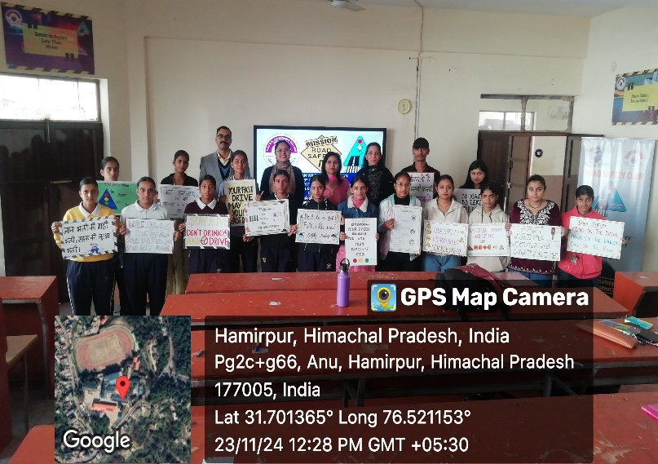 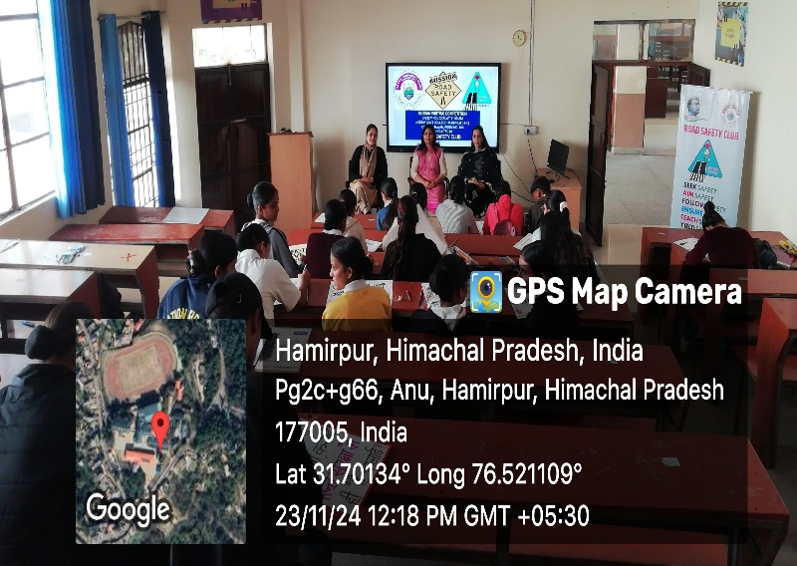

RSC Coordinator Principal

